Training materials for seminars
Discipline “Safety of GMO and organic products

Sem 1. Food security is one of major concerns for the growing global population Seminar 1. Food security is one of major concerns for the growing global population
What is genetic engineering?
Is the creation of GMOs a biotechnological process?
Seminar 2. Theme The elements needed for the safety assessment of GM crops for animal feed purposes.
What is the target organism and the donor organism?
2. How and for what purpose is recombinant DNA obtained?
3. What enzymes are used to obtain recombinant DNA?
4. What is a genetic construct? Vector? What types
vectors are used to produce transgenic organisms?
5. What are the advantages and disadvantages of different types of vectors?
6. How are genetic constructs cloned? How are you imagine the technology of molecular cloning?
7. What is polymerase chain reaction (PCR)? How synthesize genes using PCR?
8. What is a knockout gene?
Seminar 3. Theme: The current practice of safety assessment is that the product would be subjected to, as the baseline.

How to detect for GMO
Since the difference between the native plant and GM counterpart is based on DNA, the direct method for detection is also DNA based. The best technology to perform DNA analysis in routine labs is real-time polymerase chain reaction (PCR)—a high specificity and sensitivity is combined with affordable, user-frindly handling and easy data interpretation.
Seminar 4. Theme Different breeding techniques and its requirement for safety assessment before commercialisation.
What are the main types of transfer of genetic constructs in target organism? How do they differ in efficiency? Is it possible to transfer the transgene without the use of vector?
2. Name and describe the main plasmid vectors, used in genetic engineering.
3. Which bacteria is called a natural genetic engineer plants? What types of plasmids are found in agrobacteria?
How are they organized?
4. What are the reasons for the formation of tumors in plants, infected with agrobacteria? What genes does the T region carry?
Ti-plasmids?
5. Activity of what genes and products of their expression provides transfer of plasmids from agrobacteria to plants?
6. What are the main ways of transformation of prokaryotes?
Seminar 5. Theme Comparison of qPCR, ddPCR and NGS.
Currently, qPCR is the standard method used in national reference laboratories for detection and quantification of GM events. The requirement for reference material to be used as calibrants, which sometimes are not commercially available, limits its effectiveness.
The GM product detection process followed by national reference laboratories consist of two consecutive steps; first, a qPCR screening of vectors commonly found in GM products, such as the 35S promoter from cauliflower mosaic virus, Agrobacterium tumefaciens (tNOS) and selectable markers. Then, the samples with a potential presence of GM materials, are tested using the corresponding GM event-specific method.
Droplet digital PCR (ddPCR) technologies use the same DNA amplification principles as qPCR, but the technologies can provide a higher quantification precision through partitioning PCR mix into thousands of nanoliter-sized droplets in which PCR amplification is carried out. Features such as absolute quantification, avoidance of using standard curves, and high resilience to inhibitors, makes ddPCR a promising alternative for GM event detection
GM traceability describes a system that enables tracking of GM food/feed products at all stages of the supply chain. Detection methods for GM products in different matrixes or substrates, such as grain, flour and forage, are not only important to ensure legality and traceability, but also to comply with GM labeling regulations (European Parliament, 2003).
Methods for GM detection and identification usually rely on certified reference materials that are in powdered form, however, routine detection must be performed in different agricultural and food products. The selection of DNA extraction protocols is of crucial importance, since the DNA can be present in low amounts, carrying inhibitors or degraded. Therefore, the extraction method should be evaluated for each agricultural product, guaranteeing high DNA yield and purity.
The method chosen to comply to traceability and labeling requirements, should be sensitive enough to detect the transgene(s) at levels below the corresponding jurisdiction tolerance threshold (e.g., 5% in US, 1% AU, and 0.9% in EU). Additionally, it should be able to detect the transgene(s) from raw agricultural commodities entering the feed production chain. For instance, fresh leaves, dry leaves (hay), pollen, seeds, tillers or stems, and forage that could enter the feed chain as unprocessed material
A qPCR is the standard method used in national reference laboratories for detection and quantification of GM events.
Droplet digital PCR (ddPCR) technologies use the same DNA amplification principles as qPCR, but the technologies can provide a higher quantification precision through partitioning PCR mix into thousands of nanoliter-sized droplets in which PCR amplification is carried out. Features such as absolute quantification, avoidance of using standard curves, and high resilience to inhibitors, makes ddPCR a promising alternative for GM event detection
In recent years, significant effort has been performed to replace the time-consuming and expensive qPCR screening procedure. As a result, other technologies are been evaluated including ddPCR,
SGS, DNA enrichment approaches.
Technologies to fulfil regulatory requirements for GM food traceability have been established. The qPCR-based method is suitable for a high-throughput screening of transgene(s), and the ddPCR-based approach can provide a higher accuracy of the measured GM product concentration, especially at a low level. Although, the same approaches of GM food may be used for GM feed to comply the regulatory requirements, for GM feedstuff special considerations should be given to the use of plant parts not used for human food and by-products from other industries using GM plants.

Sem 6. Theme: Sources of risks from the production and use of GMOs. Environmental Safety Studies

Environmental risk assessments (ERA) aim to determine whether a new GM crop variety has direct effects on the natural environment.
Although a range of factors, such as effects on biodiversity, modification of soil and water quality, and disease and weed control, must be considered in this process, the major concern of ERA is gene flow (GF) of the transgene(s) to wild relatives.
GF is a result of the movement of gametes or individuals from a specific population to another, which may generate a significant change in the allele frequency of the receiving population. This phenomenon not only has been observed between populations of the same species, but also between closely related species.
In case of natural plant populations, such movement can happen via seeds, vegetative propagules or pollen and its importance varies among plant species.
General approaches to quantify GF use foreign herbicide and antibiotic resistance genes to provide insight into the rates and importance of hybridization.
However, morphological and molecular markers are also required to assist with rapid identification or to identify/confirm hybrids.

Sem 7. Theme: Using RNA interference (RNAi)-based gene suppression mechanics.

Sem 8. Theme: Genetic modificatio or genome edited.

Sem 9. Theme Production of therapeutic substances.
Sem 10. Theme Synthesis of toxic compounds by GM and organic products.
Sem 11. Theme What is organic farming and its importance for human.?
Sem 12. Theme Risk of food allergy. Allergenicity Studies
Allergenicity and toxicological studies may be assessed at once, since both are designed to detect newly expressed substances. Allergenic reactions can cause more severe symptoms, but usually to only some individuals, while toxicity is predictable and reproducible between individuals as it affects the majority of exposed individuals with only minor differences in susceptibility.
In US, concerns about potential risks for allergy have arisen from GM food crops, including one under development for several times. A 2S albumins gene from Brazil nut was introduced into a soybean cultivar, for a purpose of nutritional enhancement. The transgene products, however, were identified to have potential allergic risks for human, especially those with allergy to the Brazil nut, and development of the GM soybean cultivar was suspended (Moreno and Clemente, 2008; Delaney, 2015). Concerns for the Cry9C protein, a type of insect pest resistance protein from bacillus also arose, due to a higher stability to heat and possible prolong time for digestion (Wiedinmyer et al., 2000). As a consequence, the StarLink maize, an unauthorized maize containing the Cry9C transgene, was not approved for human consumption by the US authority (Zhang et al., 2016).
In case of a GM feed safety assessment, both human and animals may need to be included in an allergenicity study as test subjects. An allergenicity assessment for animals could be performed with a similar approach to that for human. There is, however, currently no standardized procedure to predict allergenic reactions to non-endogenous proteins even in humans. The European Food Safety Authority (EFSA) has recommended using animal models to evaluate the sensitizing potential of novel proteins on a case-by-case basis (Marsteller et al., 2015). The most common species to assess GM allergenicity are rodents, also referred to as a rat 90-day evaluation, which is now compulsory in the EU for new GM crops (Hong et al., 2017). However, the published studies on rats, mice, and pigs, aimed to assess the allergic risk of humans (Ladics et al., 2010), using animals mostly as food allergy models.
The most common approaches to assess allergenicity include amino-acid sequence homology, in vitro digestibility tests, serum screening and animal models (Van Haver et al., 2003). Amino acid sequence homology or similarity uses bioinformatic methods to determine the possibility, that a novel protein can be closely similar to a known allergen that can create a risk of cross-reactions (Naegeli et al., 2017). However, such bioinformatic methods cannot predict the likelihood that the novel protein might become a de novo allergen, so other methods like in vitro digestibility tests, serum screening, and animal models may need to be used (Ladics et al., 2010). The in vitro pepsin resistance assay is the most commonly used protein digestion test, which provide information about the susceptibility of a novel protein to digestion. This assay can be used as an additional evidence of possible adverse reactions to GM food/feed, since gastrointestinal digestion c

Sem 13. Theme Effects of regulation of organic plant production.
Organic farming is a system approach aiming at a sustainable ecosystem, safe food, good nutrition, animal welfare and social justice. Quantitatively, organic farming is still of minor importance, but it is one of the most rapidly growing agricultural sectors worldwide. The new EU ‘organic regulation’ consists of a framework regulation, complemented by implementation rules and guidelines. Other important regulations/standards are the National Organic Program of the USA, the guidelines of the Codex Alimentarius and the basic standards of the International Federation of Organic Agriculture Movements (IFOAM). Under all these standards, plant protection is strictly regulated. Organic plant protection follows a clear hierarchy: primarily, plant health is maintained by preventative measures. Only if these methods are insufficient, plant protection products may be used. However, only a very limited range of substances is authorized (substances of plant or animal origin, micro-organisms and a few other substances). In the EU, new substances can only be authorized if they are consistent with organic farming principles, necessary for sustained production, and if they are of plant, animal, microbial or mineral origin. Case studies for the codling moth and potato late blight illustrate that the practices of organic plant protection in Europe differ significantly from one country to another. The codling moth is mainly controlled by mating disruption, Bacillus thuringiensis, and Cydia pomonella granulosis virus (CpGV). To what extent spinosad will be used in the future is not yet clear, as it was authorized for organic farming only recently. To avoid the late blight epidemic, organic farmers use a variety of management practices. Within the constraints of the market, they also avoid susceptible varieties. For direct control of late blight, copper fungicides are the only plant protection products authorized in organic farming, but they cannot be used in all EU countries, and there are quantitative restrictions in some countries. KeywordsAuthorization of new plant protection products for organic farming-Codling moth (Cydia pomonella)-Organic plant protection practices-Potato late blight (Phytophthora infestans)-Regulations and standards for organic production
Sem 14. Theme Ban on pesticides in GM and organic products.
Pesticides are ubiquitous. Because they are used in agriculture and food production, pesticides are present at low levels in many of our diets. Less obvious is the fact that many people use pesticides around their homes, and even on their skin (i.e. in the form of insect repellents). According to the NIH, the health effects of pesticides are still not well understood [1]. Potential effects include cancer and damage to the nervous, endocrine, and reproductive systems. Genetically modified organisms (GMOs) are often engineered to be more resistant to pesticides or produce pesticides themselves. How are GMOs changing the landscape of pesticide usage in our crop fields, and ultimately, the pesticide dosage in our dinners?

Pesticides are substances used to repel, kill, or control animals (insecticides) or plants (herbicides) that are considered to be pests. There are different types of pesticides, which include synthetic pesticides and biopesticides (Figure 1). Pesticides are used extensively in agriculture and they are also used at a lower scale in our homes and on ourselves. According to the National Institutes of Health (NIH), the health effects of pesticides are not well understood, but their use has been associated with conditions such as cancer, diabetes, and neurological effects. GMOs have been changing the way that pesticides are used in agriculture. Herbicide-tolerant genetically modified (GM) crops have led to an increase in herbicide usage while insecticide-producing GM crops have led to a decrease in insecticides. To understand whether GMOs make us better or worse off in our interaction with pesticides, let’s explore the relationship between pesticides and GMOs in some detail.
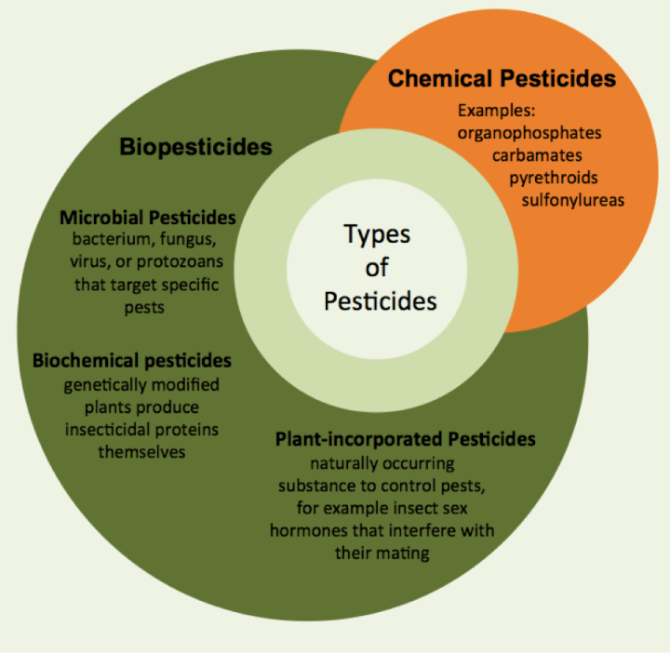

Sem 15. Theme Agri-food system safety
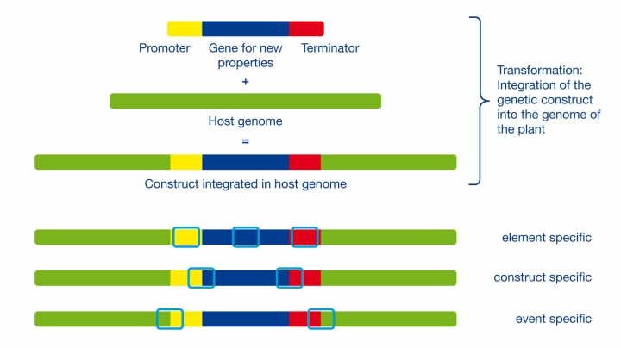
The combination of plant or host genome and integrated construct enables different levels of specificity that can be used for detection in three of the following ways:
Element specific: Single components of the construct like frequently used promoter or terminator sequences can be used. They can appear in several constructs, but also in their natural hosts (e.g. plant viruses).
Construct specific: The transitions between genetic elements of the construct, e.g. the combination of a defined promoter and a gene sequence, are suitable for the detection of distinct constructs. The constructs, however, can be used in different GMO events.
Event specific: The transition of the plant genome to the construct at the integration locus are unique for a GMO event and can be used for identification purposes.

GMO screening, identification and quantification
The purpose of a GMO screening is to detect the maximum of different events with a minimum of analytical effort. Element specific sequences are suitable screening targets since they appear in a large number of GMOs. Respective PCR systems are described in International Organization for Standardization (ISO) norms (ISO 21569, ISO 21570).
By combining a suitable number of respective targets, a relevant number of events can be identified and helpful information for subsequent identification can be gained. This approach (e.g. described in DIN CEN/TS 16707:2014-12) is based on a screening matrix — a table showing the presence of selected elements with respective GMO events. For instance, plant DNA is extracted from the sample and tested with real-time PCR for the presence of element specific markers selected from the matrix (see chart). The test result allows the exclusion of a majority of possible GMO events in the sample and shows what further screening or identification steps are useful. In addition, the matrix based approach enables further elimination of relevant events, e.g. only canola events.
Screening can be finalized by proving the presence of a distinct GMO event using an event specific target, also known as identification. If the amount of GMO is relevant, these sequences can also be used in combination with taxon (plant) specific targets to perform a quantification— copy numbers of the event and taxon specific sequences are determined using standards with known quantities. The quotient of both numbers is the 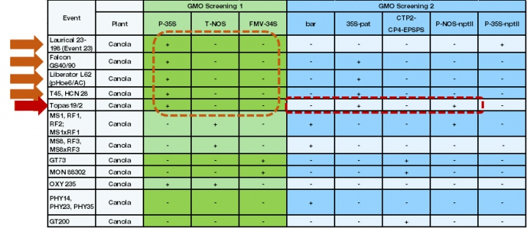 In the example (see chart), since the sample contains canola, only this part of a screening matrix is used for the interpretation of screening results. A basic screening for P-35S, T-NOS and FMV-34S GMOs reveals only the presence of the P-35S element. After the optional exclusion of naturally occurring CaMV (Cauliflower mosaic virus – the natural source for this promoter), further analysis can focus on five distinct events. A second screening analysis with further marker elements reveals the presence of 35S-pat and P-NOS-nptII and the absence of bar, CTP2-CP4-EPSPS and P-35SnptII. Based on the results, the presence of Topas 19/2 is very probable and can be proofed by an event-specific PCR system. Theoretically, a mixture of Topas 19/2 and/or other (see table) events containing only P-35S and 35S-pat is possible. relative proportion of the GMO in the sample.

”

